|  |  |
| --- | --- |
| EXP NO: 5 | Installation of hive |
|  |
| DATE: |  |

**AIM: -**

**BACKGROUND THEORY: -**

# **PROCEDURE: -**

* Switch to superuser mode using sudo su.
* Update all system packages to ensure you have the latest versions.
* Install wget to download files from the internet.
* Use wget to download the Apache Hive binary tarball from the official website
* Extract the Hive binary tarball using the tar command.
* Move the extracted Hive directory to /usr/local/hive for proper management.
* Open the .bashrc file to set the necessary environment variables for Hive.
* After editing the .bashrc file, apply the changes by sourcing it.
* You can verify that Hive has been successfully installed by running the hive command.

# **CODING: -**

* sudo su
* **Update the system**
  + sudo yum update -y
* **Install wget**
  + sudo yum install wget -y
* **Download Apache Hive**
  + wget <https://dlcdn.apache.org/hive/hive-3.1.3/apache-hive-3.1.3-bin.tar.gz>
* **Extract the Hive tarball**
  + tar -xzvf apache-hive-3.1.3-bin.tar.gz
* **Move to root directory**
  + sudo mv apache-hive-3.1.3-bin /usr/local/hive
* **Configure Hive Environment Variables**
  + nano ~/.bashrc
  + Add the following in that file as #Hive Variables
    - export HIVE_HOME=/usr/local/hive
    - export PATH=$PATH:$HIVE_HOME/bin
    - export HADOOP_HOME=/usr/local/hadoop   # Adjust to your Hadoop installation path
    - export PATH=$PATH:$HADOOP_HOME/bin:$HADOOP_HOME/sbin
  + source ~/.bashrc

# **OUTPUT: -**

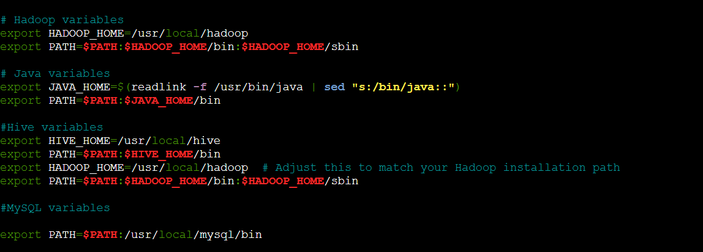

# Get Version Of Apache Hive – Big Data & SQL